SIMATS ENGINEERING
ASSESSMENT TOOL 3 – Assignment 2

COURSE NAME: STATISTICS WITH R PROGRAMMING COURSE CODE: ITA04

COURSE OUTCOME COVERED
CO3: Construct and manipulate data frames using reshaping, merging, and file I/O
operations in R to prepare structured datasets for analysis.. (BL3, BL5)
Assessment Tool Weightage: 20%

QUESTIONS: 5 Total Marks: 100

Annexure
Assignment 2

Code of Conduct:
I Syed Aakif Hussain .S. A (192525472) certify that this submission is my original work and that I have adhered to the guidelines specified for this assessment. I understand that any violation of academic integrity rules will result in disciplinary action.
Signature of the student:

Assignment 2:
- Generate 5 Questions for your Capstone Project module
- Apply the formulae and use the relevant graph to visualize it
- Upload the file in GitHub link
- Save the 5 Questions and GitHub link in the Excell sheet

ITA0408 - Statistics with R Programming
Name : Syed Aakif Hussain. S. A
Reg. No : 192525472
Title - CareerIQ: Student Placement and Career Recommendation
Module 2: Career Recommendation, Skill Analysis & Interactive Dashboard
Dataset Used : https://www.kaggle.com/datasets/sahilislam007/college-student-placement-factors-dataset

1) Which student skill area—academic performance, communication skills, or project experience—has the lowest average normalized score, indicating a potential area for improvement?
Test: Min-Max Normalization and Comparative Skill Analysis
Formula:
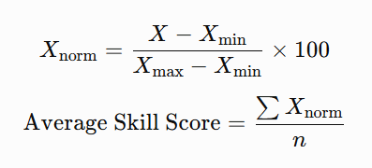

Formula Explanation
- $X$: Individual student's score.
- $X_{min}$: Minimum score in the dataset.
- $X_{max}$: Maximum score in the dataset.
- $X_{\text{norm}}$: Normalized score between 0 and 100.
- $n$: Number of students.
Graph: Bar Chart of Average Normalized Skill Scores

Code:
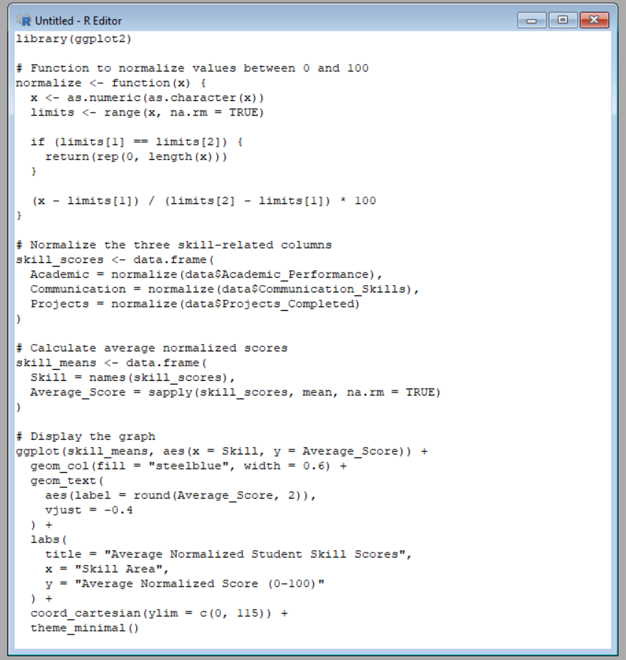

Output:
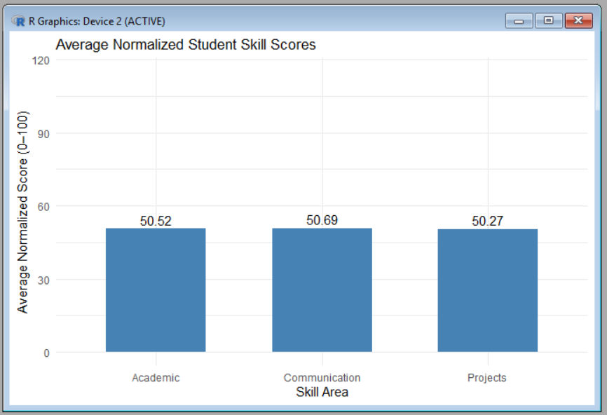
2) How many students fall into low, moderate, and high career-readiness categories based on their academic performance, communication skills, and project experience?
Test: Weighted Scoring Model
Formula:
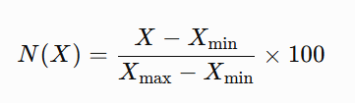
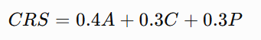

Formula Explanation
- $CRS$: Career-readiness score.
- $A$: Normalized academic performance.
- $C$: Normalized communication score.
- $P$: Normalized project experience.
Graph: Bar Chart of Students by Career-Readiness Category
Code:
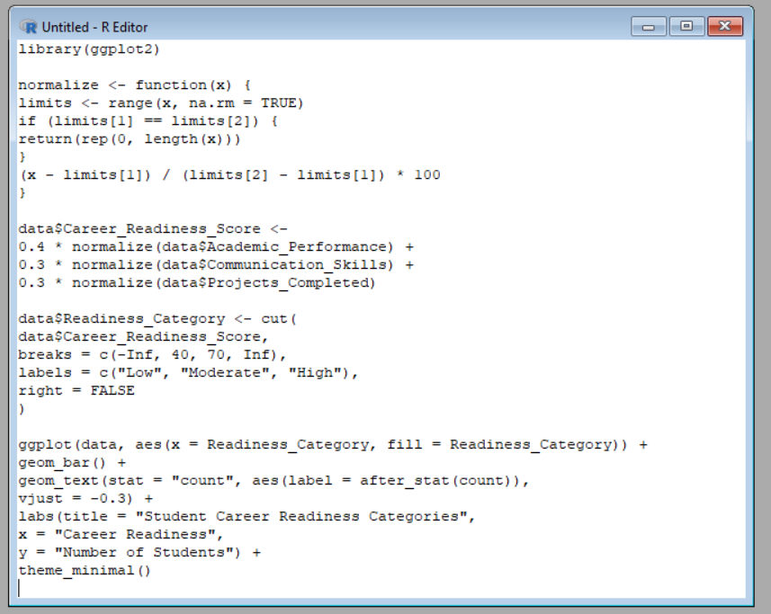
Output:
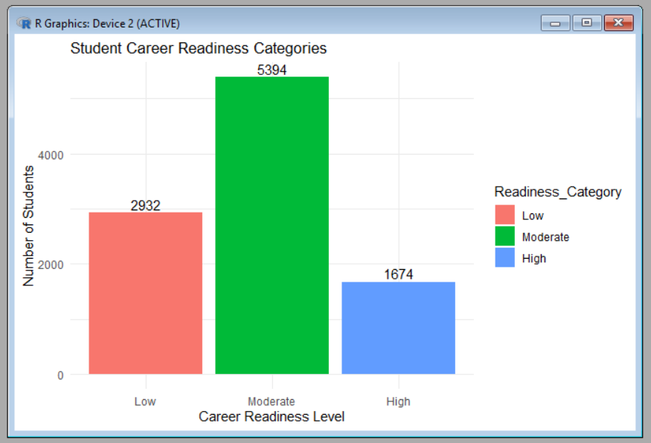

3) Is there a significant difference in career-readiness scores between students with internship experience and those without it?
Test: Independent Samples t-test
Formula:
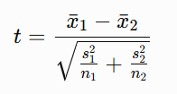

Formula Explanation
- ${\overline{x}}_{1},{\overline{x}}_{2}$: Mean career-readiness scores of the two groups.
- $s_{1},s_{2}$: Standard deviations.
- $n_{1},n_{2}$: Group sizes.
Graph: Box Plot with t-statistic and p-value
Code:
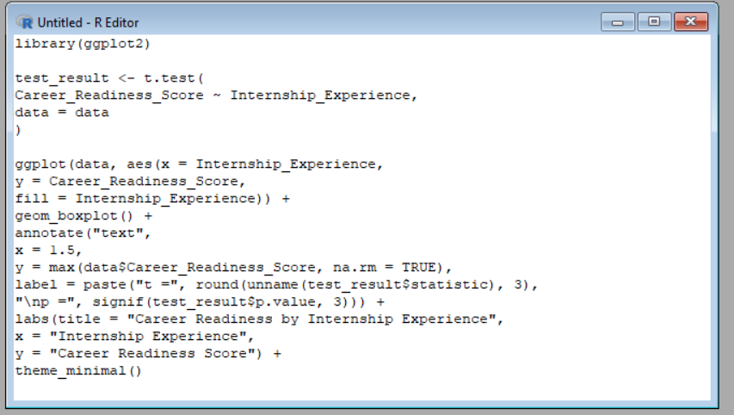

Output:
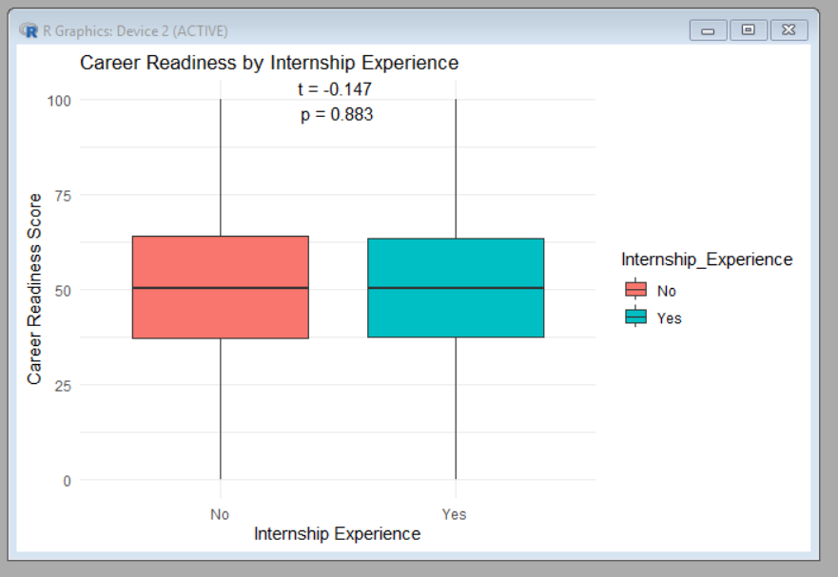

4) Is career-readiness category (low, moderate, or high) associated with placement status?
Test: Chi-square Test of Independence
Formula:
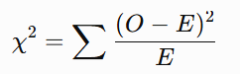

Formula Explanation
- $O$: Observed number of students in each category.
- $E$: Expected number if career-readiness category and placement status were independent.
- $χ^{2}$: Chi-square statistic.
Graph: Grouped Bar Chart with Chi-square Statistic and p-value

Code:
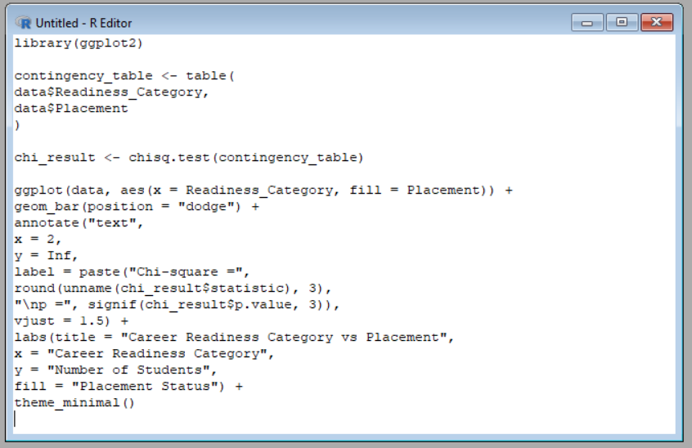

Output:
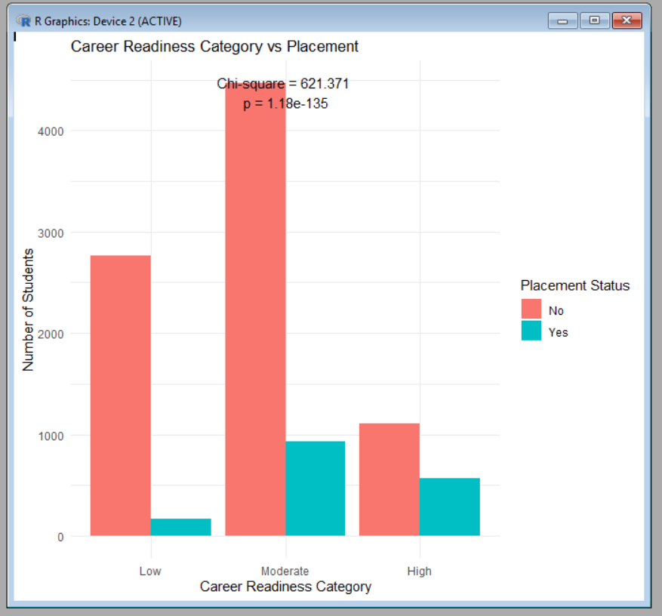

5) Do students with different academic performance scores have significantly different career-readiness scores?
Test: One-Way Analysis of Variance (ANOVA)
Formula:
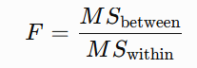
Where:
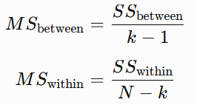

Formula Explanation
- $F$: ANOVA F-statistic.
- $SS_{\text{between}}$: Variation between group means.
- $SS_{\text{within}}$: Variation within groups.
- $k$: Number of academic performance groups.
- $N$: Total number of students.
Graph: Box Plot with F-statistic and p-value
Code:
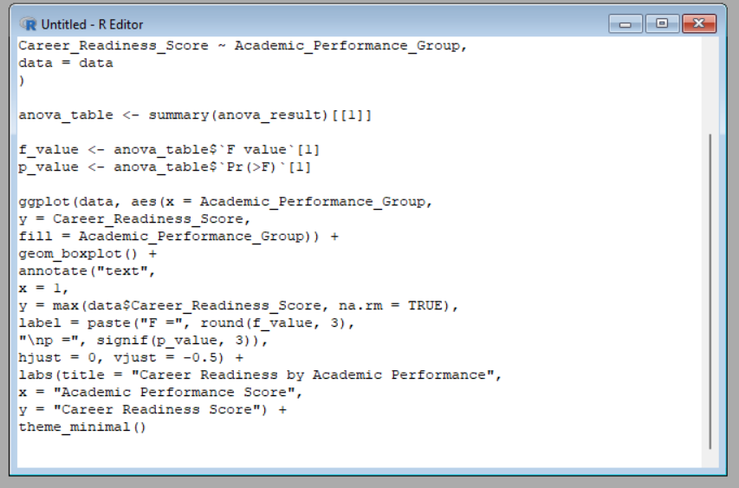

Output:
